**Experiment No. 3**

**Name: Sumit Prabhakar Kamble.**

**Roll_no: 47**

**Div: B Batch: B2 Class: TY CSE**

**PRN: 21ST114282045**

**Title: Implement Synonyms, Sequences, Triggers and Packages in PL/SQL.**

**Problem Statement:**

**Implement Synonyms, Sequences, Triggers and Packages for a given set of questions.**

**Questions:**

**1. Create a table student with attributes id, roll_no, name, address, contact.**

CREATE TABLE student2

(

id number primary key,

roll_no number,

name varchar2(20) not null,

address varchar2(50) not null,

contact number(10)

);

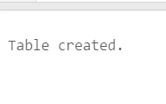

**2. Create a sequence to generate ‘id’ of a student automatically.**

create sequence stud_seq start with 1 increment by 1;

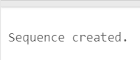

**3. Insert following values in ‘Student’ table.**

|  |  |  |  |  |
| --- | --- | --- | --- | --- |
| **id** | **roll_no** | **name** | **address** | **contact** |
| Generated via a sequence | 1 | Sumit | Mumbai | 9867585786 |
| Generated via a sequence | 2 | Shubham | Pune | 8867585756 |
| Generated via a sequence | 3 | Raj | Kolhapur | 7686758578 |
| Generated via a sequence | 4 | Andrew | Sangli | 9967585786 |

insert into student2 values (stud_seq .nextval,1,'Sumit','mumbai',9867585786);

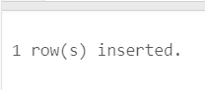

insert into student2 values (stud_seq .nextval,2,'Shubham','pune',8867585756);

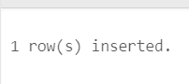

insert into student2 values (stud_seq .nextval,3,'Raj','kolhapur',7686758578);

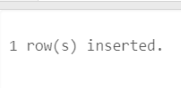

insert into student2 values (stud_seq .nextval,4,'Andrew','sangli',9967585786);

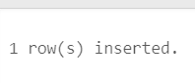

select * from student2;

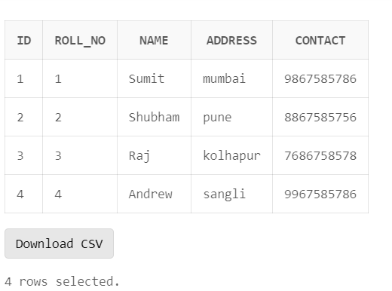

**4. Create a trigger to prompt an error message when value entered for roll number is 0.**

create or replace TRIGGER display

before insert

on student2

FOR EACH ROW

WHEN(new.roll_no=0)

BEGIN

raise_application_error(-20000,'invalid input!');

END;

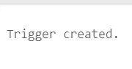

**5. Instantiate the created trigger by passing roll number of a student as 0.**

insert into student2 values (stud.nextval,0,'rani','mumbai',9867595786);

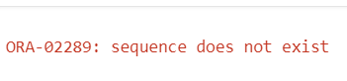

**6. Create a synonym ‘Stud’ for ‘Student’ table.**

create SYNONYM stud2 for student2;

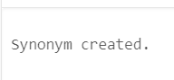

**7. Print the table ‘Student’ and ‘Stud’.**

select * from stud2;

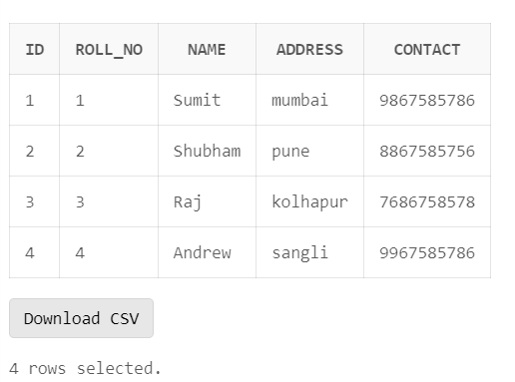

**8. Create a package with following procedures:**

**a. Create a procedure to find name of the student if roll number is given.**

**b. Create a procedure to delete a student record if roll number is given.**

create or replace package pack

as

Procedure proc1

(s_rno student2.roll_no %type);

procedure proc2

(s_rno student2.roll_no %type);

END;

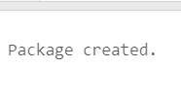

//Package body :

create or replace package body pack as

Procedure proc1

(s_rno student2.roll_no %type

)

IS

s_name student2.name %type;

begin

select name into s_name from stud2 where roll_no=s_rno;

dbms_output.put_line(s_name);

end;

procedure proc2

(s_rno student2.roll_no %type

)

IS

begin

delete from stud2 where roll_no=s_rno;

end;

end;

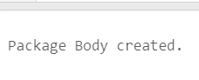

**9. Find name of the student whose roll number is 2 using a procedure created in a package.**

begin

pack.proc1(2);

end;

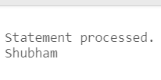

**10. Delete a student record whose roll number is 4 using a procedure created in a package.**

begin

pack.proc2(4);

end;

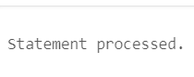

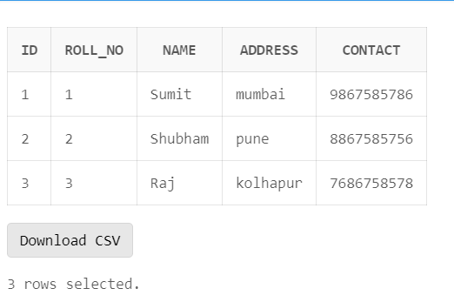

**11.Truncate the table**

begin

execute immediate 'truncate table student2';

end;

